Historical and Cultural References in the Play

(or, Where did they come up with that?)

The playwrights mix-and-mix-up popular culture icons throughout the play in an avowed effort to get cheap laughs. Depending on one’s age, theatre-goers may or may not understand the allusions or understand them differently than someone sitting next to them. As the following listing makes clear, the playwrights exhibit a weird fascination with American history and culture. Taken together, the numerous allusions separate into several themes (e.g., Americans’ attraction to conspiracy theories; the emergence of “political correctness”; no shame in going for a laugh).

See the Introduction and Context of Boomer Humor for more weighty analyses. For our audience, this page is for having fun: Older boomers might rekindle some memories; younger patrons might learn more than they want to about the upbringing of their parents and grandparents…. The actors, the director, and the designers will/have used this page for background material and inspiration.

How to Use this Site: If you have a specific question from seeing the play, you might use the “Edit”—“Find” feature and type in the word/phrase and click “Find Next.” Otherwise, you might enjoy just scrolling through the allusions noted below. If you have a question or want to challenge an assertion or add something, send an e-mail to childs.1@osu.edu

Re: the U.S. Flag: http://www.usflag.org/

Act I

Introduction (pp. 1-4)

The words with proper emphasis to “The Star Spangled Banner” may be found here: StarSpangledBanner

p. 3: “ … like that old saying: ‘Those of us who forget the past are doomed to, you know, forget like other things, ….”

Here is the original quotation: "Progress, far from consisting in change, depends on retentiveness. Those who cannot remember the past are content to repeat it." Santanya, George from: http://www.wfs.org/Q-rs.htm#s

p. 4: The U.S. was not the world’s first democracy, of course; scholars usually cite Athens, Greece, as the first democracy.

“American Gladiators” was a television show in the 1990s.

From: http://www.tv.com/american-gladiators/show/13743/summary.html

“American Gladiators was physical competition show where two male contestants & two female contestants pitted their strength, speed and skill against the highly trained pro athletes, the American Gladiators.
American Gladiators first premiered in January of 1989 along with RollerGames. It orginally started out in a Colosseum-like setting at Universal Studios consisting of a team of male and female "gladiators" attempting to wreak bodily harm on teams of challengers chosen at regional tryouts.
In the first season the events included The Joust, The Assault, Powerball, The Human Cannonball, Breakthrough and Conquer and the Eliminator….” [208 episodes]

p. 4: McDonald’s, Coca-Cola, Big Bird, and Bart Simpson were created by Americans.

Amerigo Vespucci (pp. 4-9)

Much is in dispute as to who Amerigo Vespucci was and what exactly he did. He did not name North and South America, of course. This is from an Italian site [http://www.tricolore.net/cgi-bin/display_celeb.html?c=7]

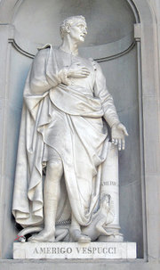 Statue at the Uffizi, Florence. From: http://en.wikipedia.org/wiki/Amerigo_Vespucci

Vespucci, Amerigo
Born: 1454
The explorer after whom the Americas are named.
Born in Florence, Italy.
Amerigo Vespucci was a Florentine merchant and navigator who made at least two transatlantic trips to the New World, voyages that inspired cartographer Martin Wardseemüller to label the new continent "America" in 1507. Vespucci was employed by the Florentine Medici family as a representative for their operations in Seville, Spain. He went from supplying ships to joining the expedition of Alonso Ojeda as a navigator. Although the record is unclear, it is generally accepted that Vespucci sailed with Ojeda to the northeastern coast of South America in 1499, under the flag of Spain. He made a second voyage in 1502. The story that he reached South America in 1497 is held to be apocryphal; the story that he made a fourth voyage in 1504 is also considered suspect. Somehow an account of a 1497 voyage was published, and Wardseemüller came to believe that Vespucci had commanded the expedition and had reached the New World before Christopher Columbus, who found the mainland in 1498. Wardseemüller named the continent America and the label stuck.
Vespucci is said to have made a guess at the world's circumference that was accurate within 50 miles. His real achievement seems to be that he concluded America had to be a new continent and not the eastern part of Asia, as Columbus believed. An honored citizen in Spain, Vespucci spent the years after his voyages as a maritime official for King Ferdinand.

p. 8: The script may begin with “Ghost Riders on the Range” … Then it clearly goes into the melody from the television comedy series, Gilligan’s Island, which aired from 1964 to 1967. [http://www.tv.com/gilligan-s-island/show/599/summary.html]

p. 9: The reference to “Mundus Novus” is not Latin for “giant nose,” but rather a reference to “new world,” which is the title of one of Vespucci’s letters (or not, perhaps). http://en.wikipedia.org/wiki/Amerigo_Vespucci

What is an American? (pp. 9-12)

p. 9: The Flip Chart rolls on for the first time …. As the flip chart is employed several times in the production, we offer the following primer on the “flip chart” at this link:

FlipChart

p. 10: “… we later sent them Jerry Lewis.”

“In March 2006 the French Minister of Culture awarded Lewis the 'Legion of Honor' calling him the 'French people's favorite clown.' [1] Liking Lewis has long been a common stereotype about the French in the minds of many Americans, and is often the object of jokes in U.S. pop culture.” [quoted from http://en.wikipedia.org/wiki/Jerry_Lewis; see also http://news.bbc.co.uk/2/hi/europe/4814232.stm]
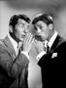
Dean Martin and Jerry Lewis, 1956.
Photo Date: 1956
Photo by Bud Fraker - All Rights Reserved, MPTV - Image courtesy MPTV.net

The director, actors, dramaturg, and other creative team members shamelessly relied on this site when editing this scene for the contemporary audience:

http://www.anagramgenius.com/

The Spiro Agnew anagram came from that site (as did the Ronald Wilson Reagan anagram at the end of Act I).

p. 11: How many names does Christopher Columbus have?:

The name Christopher Columbus is the anglicization of the Latin Christophorus Columbus. Also well known are his name's rendering in modern Italian as Cristoforo Colombo and in Castilian Spanish as Cristóbal Colón. From: http://en.wikipedia.org/wiki/Christopher_Columbus

p. 11: “… because the Vikings, the Japanese, and the Irish were probably here before him, and there was a native population of over ninety million people here before he arrived.”

The Vikings are generally credited with visiting North America well before Columbus. See this site at the Smithsonian: http://www.mnh.si.edu/vikings/start.html

There is a recent controversy begun by Gavin Menzies, a British naval author, who claims on thin evidence that the Chinese landed on the west coast of North America in 1421. This is the “1421 Hypothesis.” See http://www.1421.tv/ for Menzies’ site, and http://en.wikipedia.org/wiki/1421_hypothesis and http://www.1421exposed.com/ for an overview and criticism. Serious scholars do not take the “1421 Hypothesis” seriously.

As for the Irish, see http://www.aislingmagazine.com/aislingmagazine/articles/TAM17/Columbus.html and decide for yourself ….

Estimates of the population in North America when Columbus arrived range from 2 to 18 million. Estimates for all of the Americas vary from 40 million up to 90 million; we just do not know the answer specifically. Neither do we know when the peak of Native American population occurred.

See http://encarta.msn.com/encyclopedia_761570777/Native_Americans_of_North_America.html for a reasonable overview and http://www.carnegielibrary.org/subject/history/precolumbus.html for some good sources (web and books).

See also http://americanindianstudies.osu.edu/

p. 11: “That is so Eurocentric.” This refers to the “western” focus on the world, as seen in the way maps are constructed; in the manner in which the West (U.S. and Europe) interacts with the rest of the World, in the “core” of general education curricula at universities before the 1970s, which focused on “Dead White Males”; and in the naming of the continents. “Triumphal history of the West” is a synonym for “Eurocentric.” See the following link for an extended discussion and more links: Eurocentrism

Native American Folklore (pp. 12-16)

pp. 12-13: For a concise overview of when the “First People” came to North America, see the citations above for p. 11 and http://www.ucalgary.ca/applied_history/tutor/firstnations/theories.html.

For another interesting view of the issue, see http://www.native-languages.org/bering.htm and the links furnished.

Sometime before the last ice age ended is the generally agreed upon time frame; so, our boys got it correct.

Continental Migration after Climatic Change
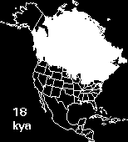  Animated Map of North America  The Recession of Glacial Ice  Courtesy of the Illinois State Museum  KYA: Thousands of Years Ago | 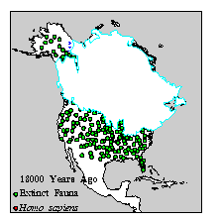  Animated Map of Human Settlement  in North America  Courtesy of the Illinois State Museum

p. 13: Crow Indians are mixed up with Pueblo Indians. Crow lived in the Yellowstone River Valley, not the Rio Grande River Valley (which is in New Mexico, where there are the San Juan Mountains, or Texas). See http://www.crystalinks.com/crow.html

p. 13: The playwrights employ “oral tradition” to tell the story of Native Americans. See http://en.wikipedia.org/wiki/Oral_tradition and http://oraltradition.org/

p. 13: From http://en.wikipedia.org/wiki/Maraca: Maracas (sometimes called rhumba shakers) are simple percussion instruments (idiophones), usually played in pairs, consisting of a dried calabash or gourd shell (cuia - 'kOO-ya') or coconut shell filled with seeds or dried beans. They may also be made of leather, wood, or plastic. Often one maraca is pitched high and the other low. The instrument is of prehistoric Moroccan origin. The word maraca is thought to have come from the Tupi language of Brazil, where it is pronounced 'ma-ra-KAH'. They are known in Trinidad as shac-shacs^{[1]}.
Although a simple instrument, the method of playing the maracas is not obvious. The seeds must travel some distance before they hit the leather, wood, or plastic, so the player must anticipate the rhythm. Bandleader Vincent Lopez hosted a radio program in the early 1950s called Shake the Maracas in which audience members competed for small prizes by playing the instrument with the orchestra.
Maracas are heard in many forms of Latin music and are also used in pop and classical music. They are considered characteristic of the music of Colombia, Venezuela, and Brazil. In rock and roll, they are probably most identified with Bo Diddley. Electronic Maracas are the main input device in the videogame "Samba De Amigo" developed by Sega.
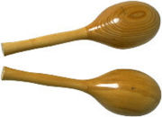

pp. 15-16: The balloon dog: This comes from the clown tradition of the playwrights (see biography link and http://www.geocities.com/heartland/plains/4030/balloon.htm).

http://www.geocities.com/heartland/plains/4030/dog.htm for how to twist a weiner dog balloon.

p. 16: “Earth, Wind, and Fire” is a 35-year-old rock ‘n roll band: http://www.earthwindandfire.com/

The Early Settlers (pp. 16-19)

p. 16: “John Cabot” was the English explorer, not Sebastian Cabot, who, perhaps, was best known for his performances on” Family Affair,” a television series, 1966-1971.

http://en.wikipedia.org/wiki/Sebastian_Cabot_(actor)

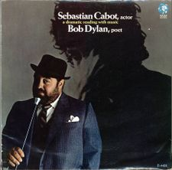

For John Cabot (whose real name was Giovanni Caboto—yes, another Italian ) see http://www.heritage.nf.ca/exploration/cabot.html

From that site, moreover, note this about John’s son, Sebastian:

Sebastian Cabot
One of John Cabot's sons, Sebastian, is bound up with his father's story, and the story of the European exploration of North America. So much so that for many years people confused father and son, and thought it was Sebastian, not John, who had crossed the North Atlantic in 1497 and 1498. How did this come about? And did Sebastian sail with his father on his expeditions?
It is now known that Sebastian was born in Venice, probably around 1484. He later moved to Bristol with his family, and would only have been 13 or 14 years old in 1497. It is possible he was on board the Matthew, but unlikely. The only supporting evidence is a 1544 map showing parts of North America which bears the legend: "This land was discovered by John Cabot the Venetian and Sebastian Cabot his son." But why the confusion between John and Sebastian? John Cabot did not return from the 1498 voyage, and his sons made no effort, so far as we know, to preserve his memory. Indeed, Sebastian, who became a mariner and explorer himself, seems to have encouraged people to think that he deserved the credit for his father's exploits. No wonder chroniclers became confused.
In 1508 - 1509, backed by Bristol interests, Sebastian Cabot explored areas to the north of those found in 1497-98, seeking a way round the new continent to Asia. He may well have sailed through Hudson Strait, turning back only because his crew refused to continue. This was the first attempt to find the northwest passage, a quest that attracted explorers for centuries. Sebastian then explored the east coast of America before returning to England.
He was unable to get further backing in England, from Bristol or King Henry VIII. As a result, from 1512 to the late 1540s, Sebastian was in the service of the King of Spain. He then returned to England, becoming governor of the Muscovy Company, which aimed to find a northeast passage to Asia, around the north of Russia. He probably died in 1557.
In 1897, the Newfoundland government issued a commemorative stamp bearing a portrait thought to be of John Cabot. It was in fact a portrait of Sebastian Cabot, painted in old age.
Sebastian Cabot.  This image of Sebastian Cabot was mistakenly identified as that of his father John on a 1897 Newfoundland stamp.  Courtesy of the Provincial Archives of  Newfoundland and Labrador (PANL A2-18).  (28 kb) | 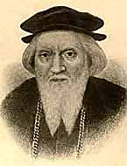
©1997, Newfoundland and Labrador Heritage Web Site Project

http://en.wikipedia.org/wiki/Ferdinand_Magellan

Sir Francis Drake may/may not have discovered San Francisco. His ship was named the Golden Hind….

p. 17: “Poetry” is the chosen “media” of this time period.

http://www.apva.org/history/index.html is a good site on Jamestown.

18: Noam Chomsky is a linguist from MIT who is a long-time critic of corporate America or, in conservative terms, “a long-time darling of the Left.”
See http://www.chomsky.info/ 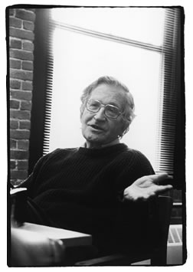

p. 18: “…
So back off buddy’ cause those Quakers were great.
They thought that killing was wrong and intolerance
rude,
But try telling that to the Puritans, dude.”

A bad rap? Well, Puritan New England was generally more intolerant of other religions than was Quaker Pennsylvania. “Religious freedom” is often associated in the American mind with New England; yet, ironically, the close relationship between religion and government in the New England colonies often led to rigid thinking and, in one case, the Salem Witch trials. Quakers were not always intolerant, of course; see Carla Pestana, Quakers and Baptists in Colonial Massachusetts (new edition 2004 paperback).

The 1692 witch trials in Salem, Massachusetts, were the supposed topic of Arthur Miller’s 1953 play, The Crucible; in reality, of course, Miller was satirizing the Red Scare and McCarthy era of the late 1940s and early 1950s . Other eras in American history related to “witch hunts”/fears of conspiracies include the 1790s, 1850s (Know Nothing anti-immigrant movement), and 1919-1920 (the First Red Scare).
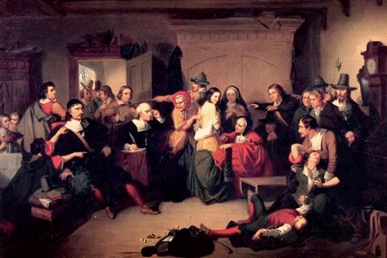 “Examination of a Witch”
From: http://www.law.umkc.edu/faculty/projects/ftrials/salem/salem.htm

p. 18: “Feral Roberts” is a pun on Oral Roberts, the televangelist who founded Oral Roberts University in Tulsa, OK, in the 1960s. http://en.wikipedia.org/wiki/Oral_Roberts

“feral”: adj. 1. wild, untamed. 2. in a wild state after escape from captivity. [from Oxford American Dictionary, 1980)…

p. 18: “… Now, to avoid tragic cases of mistaken identity …, here’s how you spot a real witch. They melt when you throw water on them, they’re surrounded by flying monkeys, [reference to Wizard of Oz] and they’re the senior Senator from the state of North Carolina. [reference to the late Jesse Helms]”

Town Crier/Shot Heard ‘Round the World (pp. 19-22)

p. 19: Playwrights have actors “reading a scroll” to depict the “media” of the time period.

“Patriots trounce the Redskins.” This references two teams in the National Football League, the New England Patriots and the Washington Redskins. Records of recent seasons suggest this is true.

“King George celebrates victory [what a choice verb!] by imposing taxes on tea, stamps, sugar, ….” This references the need in the 1760s to pay off the debt incurred by England during the Seven Years War (or the French and Indian War, as it was known in the colonies). The English American colonists believed that they had won the war with their militias and that they did not need to pay increased taxes. Actually the “increased taxes” were “decreased taxes,” only now they were to be actually collected (the previous “higher taxes” had not been collected; this was the period of “salutary neglect” of the colonies).

p. 20: Mixing stories: Boston Tea Party with the tea party in Chapter VII of Lewis Carroll’s Alice’s Adventures in Wonderland.

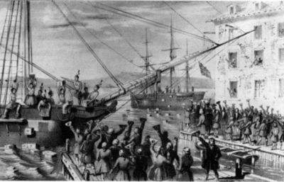
This 1846 lithograph has become a classic image of the Boston Tea Party.
From: http://en.wikipedia.org/wiki/Boston_Tea_Party

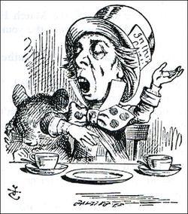 The Hatter as depicted by Tenniel
http://en.wikipedia.org/wiki/Mad_Hatter

“Hey! Did you hear?” is a classic Vaudeville joke opening.

“Paul Revere and the Raiders number one on the charts with ….” This is a reference to a 1960s band of the same name; see http://www.paulrevereraiders.com/

pp. 21-22: “Recreation of shot heard ‘round the world”: This is a spoof on Americans’ fascination with conspiracies that mixes interest in the Kennedy Assassination (1963), the mysteries of the battle at Lexington (1775),and allusions to the murder trial of OJ Simpson (1995) ( with the infamous white Bronco police chase/escort in 1994).

Minute Men (pp. 22-26)

pp. 22-23: song “Lexington League” is taken from a song in the 1939 movie, Wizard of Oz.

Many of the “little people” (over 100) were hired from a Vaudevillian company that toured Europe in the 1930s. See http://www.kansasoz.com/infomunchkins.htm

Frank Baum’s book, The Wonderful Wizard of Oz (1900) has been analyzed as an allegory that reveals the nature of American politics in the 1890s, with the “wizard” and the “Emerald City” representing a conspiracy among politicians and corporations to control the people.

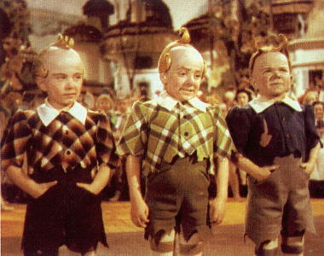
The Lollipop League
Harry Doll, Jerry Maren, and Jackie Gerlich from: http://www.kansasoz.com/infomunchkins.htm

Another source has these lyrics: http://thewizardofoz.warnerbros.com/movie/cmp/r-lyrics.html

(Lullaby League)
We represent the Lullaby League
The Lullaby League, the Lullaby League
And in the name of the Lullaby League
We wish to welcome you to Munchkin Land
(Lollipop Guild)
We represent the Lollipop Guild
The Lollipop Guild, the Lollipop Guild
And in the name of the Lollipop Guild
We wish to welcome you to Munchkin Land

p. 23: “mahogany-mouth” refers to George Washington’s mythical “wooden teeth.” In fact, he had two sets of dentures made from ivory and gold. See http://www.goodteeth.com/gwteeth.htm and http://www.msnbc.msn.com/id/6875436/

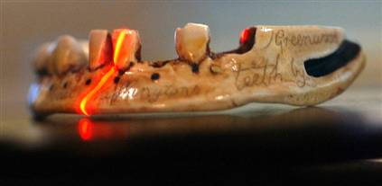
Light from a red laser scans a resin reproduction of the 1789 lower denture originally carved from Hippopatamus ivory for George Washington.
Jed Kirschbaum / The Baltimore Sun http://www.msnbc.msn.com/id/6875436/

p. 24: “This is a clear case of Vertical Discrimination.” Part of the play’s satire of “political correctness.”

p. 26: Virginia was named after Elizabeth I, the “Virgin Queen.”

p. 26: “I can not tell a lie!” Mythical statement about cutting down his father’s cherry tree attributed to George Washington in his youth by biographer Mason Weems. See http://xroads.virginia.edu/~cap/gw/weems.html A History of the Life and Death, Virtues and Exploits of General George Washington By Mason Locke Weems. Published in Philadelphia by J.B. Lippincott Co. in 1918.

Betsy Ross (pp. 26-27)

p. 26: Marion Ross: Actress who played Marion Cunningham on “Happy Days” television show. http://en.wikipedia.org/wiki/Marion_Ross

p. 27: http://www.foundingfathers.info/stories/gadsden.html#history furnishes a rather intense review of the “snake” image in colonial America, leading up to the “Don’t Tread on Me” flag mentioned in the play. Benjamin Franklin has a central role in this story.

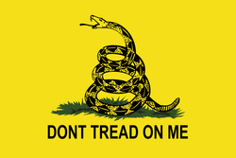 See also: http://en.wikipedia.org/wiki/Gadsden_flag

p. 27: “…the Yankees had won.”

The origin of the term “yankee” is not agreed upon, but the time-frame is probably correct. “Yankee” refers to Americans from New England, so the reference leaves out the Americans from the South …. See Oxford English Dictionary: http://dictionary.oed.com/cgi/entry/50288716?query_type=word&queryword=Yankee&first=1&max_to_show=10&sort_type=alpha&result_place=1&search_id=NDBx-9DSu4t-3978&hilite=50288716 and http://en.wikipedia.org/wiki/Yankee

Bill of Rights (pp. 28-31)

For information on the Bill of Rights, see Bill of Rights.

p. 28: “… you’re staying alive, staying alive.”
“No, that’s too seventies.”

This refers to the Bee Gees “Staying Alive,”1983. See for lyrics http://www2.uol.com.br/cante/lyrics/Bee_Gees_-_Staying_alive.htm and for Bee Gees http://www.beegees-world.com/

p. 28: “This is great tobacco, Jefferson. Grow this yourself?”

Jefferson’s Poplar Forest plantation grew tobacco. Growing of tobacco spread from the Americas throughout Europe. Amerindians employed tobacco for ritual and healing purposes; EuroAmericans(16th-18th centuries) believed the plant had many medicinal purposes. In the 19th century tobacco’s addictive properties were discovered. See http://academic.udayton.edu/health/syllabi/tobacco/history.htm#begin and http://www.tobacco.org/History/history.html

p. 28: “Monticello Gold. Do you suppose Dolley Madison has any more of those cakes?”

“Monticello Gold” refers to “street” names for different kinds of marijuana, e.g. “Acapulco Gold.”

p. 28: Reference to Dolley Madison’s cakes: From: http://www.dollymadison.com/:
“Cakes and pastries fine enough to serve at the White House.” That is how Roy Nafziger, IBC’s founder [Interstate Bakeries Corp], described his Dolly Madison® snack cakes at their introduction in 1937. Roy’s fascination with the First Lady Dolley Madison lent him the name and inspiration to create a high quality snack fit for a socialite like Madison yet affordable for everyone. [emphasis added]
“Today, Dolly Madison Bakery® products have grown to include Zingers®, Donut Gems, Angel Food and Pound Cakes, and a variety of breakfast items like Sweet Rolls, Dunkin Stix and Pecan Rollers.”
See this recent article on Dolley Madison and advertising: http://www.madisonavenuejournal.com/2006/03/25/dolley_madisons_avenue/index.php

p. 30: “You can show that same nipple being lopped off with a chain saw, but you can’t kiss it.”

This refers to the MPAA (Motion Picture Assoc. of America) rating system, which appeared in the late 1960s to help guide audiences in choosing which films to see or not see. Today there are G, PG, PG-13, R, NC-17 ratings. See these and associated links: http://en.wikipedia.org/wiki/MPAA_film_rating_system#Original_ratings and http://en.wikipedia.org/wiki/Production_Code

p. 31: Aretha Franklin’s song, “Respect,” was a #1 hit in the 1960s and earned her two Grammy Awards in 1968. She had four sons. http://www.lyricsdepot.com/aretha-franklin/ for lyrics.
http://www.aretha-franklin.com/bio.htm; http://en.wikipedia.org/wiki/Aretha_Franklin
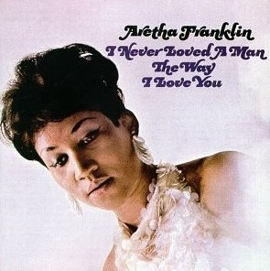

Lewis and Clark (pp. 32-37)

An early inspiration for this scene’s characterizations was the comedy team of Jerry Lewis (see above) and Dean Martin. [“Commentary,” CHAa DVD] The director and actors watched old Martin and Lewis bits for inspiration.

The vaudeville routine carries the information; use of sound effects with sound-making devices (cymbals, slide whistle, bike horn)is vaudevillian as well.

p. 32: “… purchased the Louisiana Territory from France for about fifteen million dollars, or roughly three cents an acre.” Correct.

For Lewis and Clark, see http://www.lewis-clark.org/; http://www.pbs.org/lewisandclark/; http://www.nationalgeographic.com/lewisandclark/

Cucamonga is in Southern California, a place Lewis and Clark did not visit.

Jimmy Durante: http://en.wikipedia.org/wiki/Jimmy_Durante

p. 34-36: “squaw”: The playwrights have hit upon an interesting controversy, with scholarship apparently taking a backseat to political correctness. See this link:
ObjectiontoSquaw
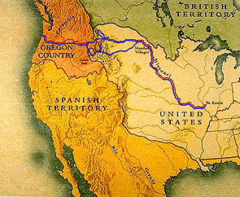
http://www.pbs.org/lewisandclark/inside/index.html

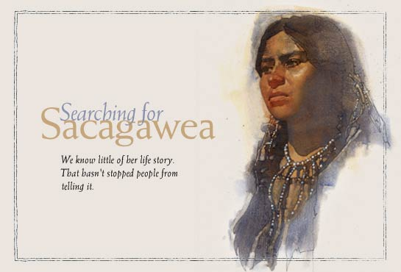
http://magma.nationalgeographic.com/ngm/0302/feature4/index.html

New National Anthem (pp. 37-39)

p. 37: “Born in the USA” is a song by Bruce Springsteen http://www.brucespringsteen.net/songs/BornInTheUSA.html

p. 38: “Freebird” is the classic instrumental by Lynard Skynyrd band http://www.lynyrdskynyrdhistory.com/:

[emphasis added below]

CONGRATULATIONS To Lynyrd Skynyrd!
2006 Inductees Into The Rock & Roll Hall Of Fame
Ronnie Van Zant - Gary Rossington - Allen Collins - Leon Wilkeson
Bob Burns - Billy Powell - Ed King - Artimus Pyle - Steve Gaines
Lynyrd Skynyrd was one of the most commercially successful and critically acclaimed Southern Rock groups of the 1970's. Their distinctive triple-lead guitar sound made their songs "Freebird" and "Sweet Home Alabama" American anthems and staples of FM radio. Artists become eligible for induction 25 years after the release of their first record. Criteria considered includes the influence and significance of the artist's contribution to the development and perpetuation of rock and roll. The Foundation's nominating committee, composed of rock and roll historians, selects nominees each year in the "artist" category. Ballots are then sent to an international voting body of about 700 rock experts. The Twenty-First Annual Induction Ceremony was held on March 13th 2006 in New York, the ceremonies were aired a week later on March 21st, by VH1.

p. 38: “Snowbird” by Anne Murray http://www.annemurray.com/

p. 38: “ambigenic”:

See this site for a rewriting of the Declaration of Independence: http://www.crazypolitics.co.uk/ [notice the country of origin ….]

This site puts ambigenic into a circular, sexual context: http://www.stanleykrippner.com/papers/circle.htm See also: http://psiona.50megs.com/photo6.html

This site defines ambigenic as “non-sexist”: http://books.google.com/books?id=Q440jZBUpsMC&pg=PA142&lpg=PA142&dq=ambigenic&source=web&ots=7fAuR4m9oa&sig=VyvR417lRzjVhXA8cMMnLa8Mndw#PPA141,M1

See this page for historical background on the song, “America the Beautiful”: AmericatheBeautiful

Civil War Slide Show (pp. 39-43)

The playwrights chose the slide show to depict the new media of the period, the photograph. Matthew Brady staged his infamous photographs of Civil War battle fields.

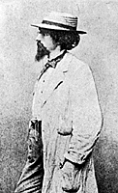 Matthew Brady, 1861 http://memory.loc.gov/ammem/cwphtml/cwbrady.html

See the following link for LC photos from the Civil War: http://memory.loc.gov/ammem/cwphtml/cwphome.html

p. 39: “ … Tyson versus Holyfield. …” 1997 fight in Las Vegas during which Mike Tyson bit Evander Holyfield’s ear (twice).

p. 40: “The importation of slaves into America was declared illegal in 1807, but the domestic slave trade continued to grow.”

The British abolished their slave trade in 1807. The Americans banned importation of slaves the same year, but not the internal slave trade.

Lincoln Assassination Ballet (pp. 43-44)

The playwrights chose the ballet to depict the Lincoln assassination. As ballet in America did not take off until after 1900, the choice is a … puzzle. Ballet was popular in Europe and especially Russia during the middle nineteenth century.

Ford Theatre: http://www.nps.gov/archive/foth/index2.htm

See this site for historical background on the Bunraku costume employed in this scene: http://www2.ntj.jac.go.jp/unesco/bunraku/en/index.html
http://www.japan-zone.com/culture/bunraku.shtml is another site of interest.

Conspiracy Theories (pp. 44-45)

Conspiracy has been a theme of the play before this scene, of course. Americans seem especially enamored with “conspiracy theories,” to the point that it is considered by some—certainly the playwrights—as a defining element of the national character.

See http://en.wikipedia.org/wiki/Category:Conspiracy_theories for a long list/descriptions of such theories and http://en.wikipedia.org/wiki/Conspiracy_theory for an interesting/exhaustive overview of the topic (with links). The latter includes this interesting take:

“Christopher Hitchens represents conspiracy theories as the 'exhaust fumes of democracy', the unavoidable result of a large amount of information circulating among a large number of people.” [Christopher Hitchens is a British-American columnist who is very much a part of the mass culture/personality culture the playwrights are satirizing.]

p. 43-45: The playwrights play-off an urban legend here. See this link: UrbanlegendsLincolnJFK

p. 45: The Trilateral Commission, the National Security Council (NSC), and the International Monetary Fund (IMF) are favorite targets of conspiratorialists’ analyses. The playwrights could have included the World Bank as well. See:

http://www.trilateral.org/; http://en.wikipedia.org/wiki/Trilateral_Commission;

http://www.whitehouse.gov/nsc/; http://en.wikipedia.org/wiki/United_States_National_Security_Council

http://www.imf.org/; http://en.wikipedia.org/wiki/International_Monetary_Fund

p. 45: “… Air Force hangar in Nevada housing alien spacecraft” refers to the infamous Area 51. See http://en.wikipedia.org/wiki/Area_51 [Note: On the day accessed, March 24, 2007, this web page had the notation: “Editing of this article by unregistered or newly registered users is currently disabled. Such users may discuss changes, request unprotection, log in, or create an account.” And “This article may require cleanup to meet Wikipedia's quality standards. Please discuss this issue on the talk page or replace this tag with a more specific message. This article has been tagged since March 2007.” … Coincidence? You decide!
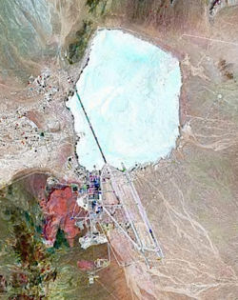

p. 45: Origin of “take a leak”: From Oxford English Dictionary On-line:
c. slang. An act of urination. Freq. in phr. to take a leak, to urinate. Cf. LEAK v. 2c.
1934 H. MILLER Tropic of Cancer 182, I stood there taking a leak. 1968 K. WEATHERLY Roo Shooter 111, I saw Sam get out of the Rover... I thought he'd got out for a leak. 1969 G. GREENE Trav. with my Aunt II. vi. 282 All these hours of standing without taking a leak. 1972 F. RAPHAEL April, June & Nov. 283 ‘The guest toilets at the Palace aren't really all that marvellous.’ ‘..Thanks for the tip, I'll remember to take a leak before I go next time.’

Intermission

Act II

World War I

pp. 47-50: Reed’s character is a satire of Lee Marvin as the Sergeant in The Big Red One (1980). See http://www.imdb.com/title/tt0080437/

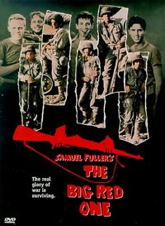

p. 48: “He doesn’t understand the complex, almost postmodern irony of a World War fought over jingoistic and chivalrous nineteenth-century ideals but using twentieth-century weapons of carnage and destruction.” [Oh, never mind.]

p. 48: “We’re expendable.” References John Wayne’s movie, They Were Expendable (1945). See http://www.imdb.com/title/tt0038160/ 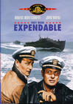

p. 48: “Very Impressionistic.” References the school of painting in France in the late 19th an early 20th century. See http://www.impressionism.org/

Monet, Autumn at Argenteuil, 1873

http://www.geocities.com/rr17bb/monet.html

p.48: “You’ve been too close to the mustard gas again.” World War I military action included the use of poisonous gas. Mustard gas was just one of numerous kinds of gases employed. See http://en.wikipedia.org/wiki/Poison_gas_in_World_War_I

p.49: “Krauts” was a World War II term for the Germans; the WW I term was “Hun.”

p.49: “ViewMaster”: http://en.wikipedia.org/wiki/View-Master The View-Master was an upgrade of the stereoscope and was introduced in 1939 at the World’s Fair in New York. It involved viewing 3D images. Ties to Walt Disney were made in the early 1950s. http://www.fisher-price.com/fp.aspx?t=page&a=go&s=viewmaster&p=landing_flash&site=us
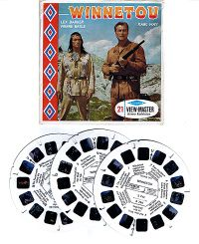

p. 50: “No, not ‘in the skies,’ in ‘disguise.’” “Lucy in the skies with diamonds.” Beatles song 1967. See Sgt. Pepper's Lonely Hearts Club Band.

See also http://en.wikipedia.org/wiki/Lucy_in_the_Sky_with_Diamonds.

There are also connections here to the drug culture of the sixties and Alice’s Adventures in Wonerland and Through the Looking Glass, both by Lewis Carroll.

p. 50: “We’re just cannon fodder for the military-industrial complex.” In his farewell address in 1961, Pres. Dwight D. Eisenhower warned the American people about the power of the “military-industrial complex” to take over the nation’s budget and politics. See “conspiracies” above.

pp. 50-52: The Andrews Sisters were, in fact, extremely popular with American troops during WW II. See http://www.cmgww.com/music/andrews/; http://www.singers.com/jazz/vintage/andrews.html (photo below)

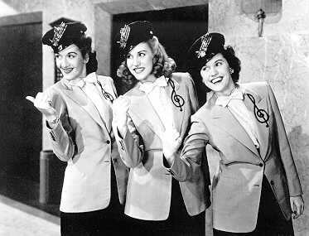

p. 51: “… over the top” NOT THE 1987 Stallone movie!! Rather, during WW I, soldiers in the trenches were ordered to go “over the top” to their certain death in charges against the enemy. Here’s an interactive web site about Canadians in the trenches: http://www.civilization.ca/cwm/overtop/about_e.html

pp. 51-52: Song references the views of “gays in the military” during WW II.

p. 52: “lock and load”: A rather deep cultural reference … as this link suggests: LockLoad

Radio Show (pp. 52-62)

See separate web page re Radio History

The playwrights mix numerous references together in the extended radio scene in Act II. Generally, they are paying homage to and satirizing the wonderful radio dramas and comedies of the 1920s, 1930s, and 1940s. Americans discovered their western heritage through Hollywood during the same time period, and early television carried that tradition forward in the 1950s and 1960s[ http://www.fiftiesweb.com/western.htm; http://www.museum.tv/archives/etv/W/htmlW/westerns/westerns.htm ].

pp. 52-53: “ America’s Favorite Cowboy, Dodge Rambler—Boy Buckaroo” references:

Gene Autry [http://www.cow-boy.com/musaut.htm];

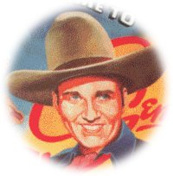

two different cars—Dodge and AMC Rambler of the 1960s [http://www.imperialclub.com/Articles/64Comparison/index.htm]; and

(perhaps?) a cult film, “The Adventures of Buckaroo Banzai Across the 8th Dimension” (1984) [http://www.imdb.com/title/tt0086856/]. [See p. 86 below ….]

p. 53: “Thunder Bread” references “Wonder Bread” http://www.wonderbread.com/ … “big where you need it”: “White” bread is more fattening than wheat bread ….

Always fresh, soft and delicious – Wonder is America’s favorite brand of white bread.
Wonder has helped America build strong bodies for over 80 years. It provides essential vitamins and minerals, an important part of your family’s healthy diet. And today Wonder is more nutritious than ever before. Every slice is an excellent source of calcium and a good source of folic acid.
Same great taste, new look! We’ve updated the look of our packages to make it easier to find your favorite Wonder white bread.
Look for our new “Wonder Classic” package 
and our new “Wonder Classic Sandwich” package at a grocer near you.

p. 54: “Gordon, my faithful and trusty steed.”:

Sons of the Pioneers & Roy Rogers (1963)

Ole Faithful, we rode the range together
Ole Faithful, in ev'ry kind of weather
When your round up days are over
There'll be pastures white with clover
For you, Ole Faithful, pal o' mine.

Hurry up ole fellow
'Cause the moon is yellow tonight
Hurry up ole fellow
'Cause the moon is mellow and bright.

There's a coyote howling to the moon above
So carry me back to the one I love
Hurry up ole fellow
'Cause we gotta get home tonight.

http://artists.letssingit.com/sons-of-the-pioneers-lyrics-old-faithful-horses-prayer-wqhzwrx

[Some evidence suggests that the origins of “faithful horse” might not be American, but rather Russian … http://www.darsie.net/talesofwonder/russia/russia.html (see no. 8).

p. 54: “Timmy’s trapped on a cliff and needs insulin?”: Classic Lassie story …: http://en.wikipedia.org/wiki/Lassie [began on radio in 1938 … ] http://www.lassie.net/


Lassie filming on location in Florida
photo courtesy State Archive of Florida

p. 55: “Lucky Stroke Cigarettes”: Lucky Strike cigarettes … from http://en.wikipedia.org/wiki/Lucky_Strike:
“In 1935, ATC [American Tobacco Co.] began to sponsor Your Hit Parade, featuring North Carolina tobacco auctioneer Speed Riggs. The weekly radio show's countdown catapulted the brand's success and would remain popular for 25 years. The shows capitalized on the tobacco auction theme and each ended with the signature phrase "Sold, American".”
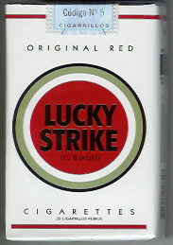

p. 55: Hoover Boys: Jedgar (J. Edgar Hoover, FBI chief) and Herbert Hoover (President).

p. 56: “Nice dress.” J. Edgar Hoover was rumored to be a cross-dresser; no credible evidence has ever materialized to substantiate this urban legend.

http://www.fbi.gov/libref/directors/hoover.htm

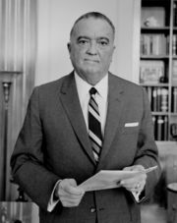 1961

p. 56: 18th Amendment did prohibit the manufacture, sale, and transportation of intoxicating liquors. It went into effect after WW I (ratified January 1919 and was repealed in 1933).

http://prohibition.osu.edu/

p. 58: Al Capone: Chicago gangster of the 1920s who made his fortune selling alcohol; responsible for Valentine Day massacre, 1929; early 1930s convicted of income tax evasion.

http://www.chicagohs.org/history/capone.html 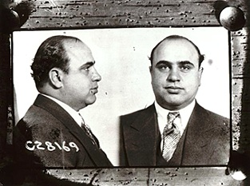

p. 58: “from the horse’s mouth”: http://www.phrases.org.uk/meanings/336400.html
From the highest authority. In horse racing circles tips on which horse is a likely winner circulate amongst punters. The most trusted authorities are considered to be those in closest touch with the recent form of the horse, i.e. stable lads, trainers etc. The notional 'from the horse's mouth' is supposed to indicate one step better than even that inner circle, i.e. the horse itself. It is a 20th century phrase. The earliest printed version I can find of it is in an piece by P. G. (Pelham Grenville) Wodehouse in The Strand Magazine, 1928: "The prospect of getting the true facts - straight, as it were, from the horse's mouth - held him fascinated." See also - don't look a gift horse in the mouth and long in the tooth.
p. 58: “Rosebud” is a reference to the 1941 film, “Citizen Kane,” by Orson Welles. http://www.imdb.com/title/tt0033467/

Nine Academy Award nominations and one win for “Citizen Kane.”

p. 59: FDR: Franklin D. Roosevelt, Pres. of USA 1933-45; polio in the 1920s put him in wheelchair. WPA, CCC, TVA: alphabet agencies that FDR and the Democrats created to try to help Americans deal with the Depression. The FBI was created in the 1920s, not under FDR; the FDIC was created in the 1930s (Federal Deposit Insurance Corporation); and the IUD is “IntraUterine Device,” a form of birth control developed over the 20th century.
“Lucy” is reference to Lucy Mercer, FDR’s close female friend/probably mistress.

p. 59: “Rock Fury, Super GI”: Perhaps this is a compilation of characters from DC Comics? See http://www.dcuguide.com/index.php

pp. 59-60: “Adolph” is Adolph Hitler and “Eva” is Eva Braun, his mistress. See “Hitler syphilis theory revived” at http://news.bbc.co.uk/2/hi/health/2842819.stm

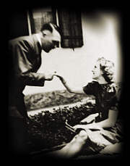 http://www.auschwitz.dk/Braun.htm

p. 60: “It’s a bird, it’s a plane …” Line introducing Super Man on television series (1951-1957). http://superman.ws/fos/thescreen/tv1/

p. 60: Argument between Rock and Eva and Adolph: Germany tried to conquer Europe, put Jews in concentration camps, and murdered 6 million Jews. Americans conquered North America, killed millions of Amerindians through contact with diseases and warfare; placed those remaining on reservations, and put 120,000 Japanese-Americans in camps during World War II.

p. 61: “Leavenworth” refers to the U.S. Penitentiary in Leavenworth, KS.

p. 61: “… we won this war; otherwise, the German and Japanese economies would dominate the world.” In the 1980s and early 1990s, it appeared for a time that the U.S. had lost its economic edge in world commerce, especially to the Japanese. Before the reunification of East and West German in 1990y, West Germany was a very strong economy as well.

p. 61: “… Alan Alda calling for help from Korea.” This refers to the character of Hawkeye, played by Alan Alda, in the television series, “M.A.S.H.” It aired from 1972 to 1983. http://www.mash4077.co.uk/index.php; http://en.wikipedia.org/wiki/M*A*S*H_(TV_series)

p. 62: “This just in ….” Turning to the popular show instead of reporting the horrifying news satirizes the choices news teams make as to what is important.

Q & A (pp. 62-68)

http://history.sandiego.edu/gen/projects/hanley/queen.html is a link to an analysis of the television show, “Queen for a Day,” “ by Shawn Hanley Dec. 16, 1996, for the Mass Media History Seminar and last modified Jan. 7, 1997.” It makes the argument that the quiz shows of the 1950s, while generally treated negatively by media critics, actually served more interests than those of the corporations that made so much money from airing them. Queen for a Day began on radio and ran on television for almost 20 years (mid-1950s to mid-1970s). One quotation from the article sums up the phenomenon:

"Sure 'Queen' was vulgar and sleazy and filled with bathos and bad taste," wrote producer Howard Blake in an article for Fact magazine. "That was why it was so successful. It was exactly what the general public wanted....We got what we were after. Five thousand Queens got what they were after. And the TV audience cried their eyes out, morbidly delighted to find there were people worse off than they were, and so they got what they were after."

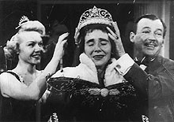

The playwrights, then, chose “Queen for a Day” as the medium through which to present their satire of the history of the mid-20th century. Given their satirical approach, the choice makes perfect sense, as these interesting tidbits from Wikipedia make clear:

Trivia & pop culture references
- Within one year of its original arrival, however, Queen for a Day was the target of a parody on The Fred Allen Show. Tying it to the humourist's longtime running-gag "feud" with fellow comic titan Jack Benny, calling the segment "King for a Day", Allen set it up for Benny (in skinflint character) to sneak his way onto the "show" as a contestant, answer a single trivia question, and win a passel of goof prizes, including a professional pressers' iron that gave Allen the excuse to catch Benny, literally, with his pants down. Allen ordered assistants to start undressing Benny so his suit could be pressed right there, with Benny bellowing, "Allen, you haven't seen the end of me!" and Allen rejoining, without missing a beat, "It won't be long now!"
- The 1951 movie Queen for a Day was based on the show and featured Jack Bailey playing himself.
- George Carlin parodied the show with "Queenie for a Day" on the "Daytime Television" segment of his debut album, Take-Offs and Put-Ons in 1967. In his version, the winning contestant tells an increasingly tragic tale of hospitalization and homelessness, yet in the end, all she requests as a prize is a set of golf clubs.
- In an 1980 episode of Happy Days, Marion Cunningham appears on a fictional Queen for a Day-like show to win funds for her son and his fiancée to get married, but she feels so sorry for one of her competitors that she turns over all her winnings to the other woman.
Retrieved from "http://en.wikipedia.org/wiki/Queen_for_a_Day"

pp. 62-63: Emma Goldman was founder of “Mother Jones” and Alexander (Sasha) Berkman was her lover. She was a feminist and anarchist; she was deported from the U.S. in 1919.
See for a beginning: http://en.wikipedia.org/wiki/Emma_Goldman
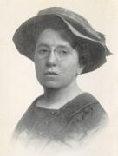 Emma Goldman

http://www.motherjones.com/

p. 63: “Blame it on Mamie.” This references First Lady Mamie Eisenhower, who supported her husband and enjoyed feminine clothes, jewelry, and entertaining …. “Progressive”—certainly not along the lines of … Emma Goldman.

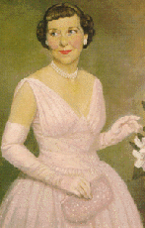

Mamie Eisenhower
http://www.whitehouse.gov/history/firstladies/me34.html

p. 64: Rosa Parks began the bus boycott in Montgomery, AL, in 1955. Martin Luther King came to prominence with this civil rights action, which lasted over a year.

 Rosa Parks, 1955, with ML King n the background.

p. 65: The first woman elected to the U.S. House of representatives was Jeannette Rankin (R-MT), who served from 1917-1919 and again from 1941-42. A pacifist, she was the only person to vote against U.S. entry into both World Wars. See http://www.cawp.rutgers.edu/factoidarchive.html Center for American Women and Politics

p. 68: Between the Civil War and World War I: There certainly was labor unrest (e.g., Emma Goldman’s life above; many strikes; failure of AFL and Knights of Labor); more land-grabbing (Cuba, Philippines; Panama); children working in factories and sweat shops.

There was more: Electricity developed; railroads connected the coasts; more fresh fruit became available year round (refrigeration); 20 million immigrants; national advertising began; airplanes flew; etc.

Spade Diamond

The playwrights chose the “Film Noir” style of writing for this scene.

See this link FilmNoir

Or

http://www.filmsite.org/filmnoir.html for a full discussion of the genre.

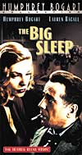

p. 69: In 2000 presidential election, Al Gore won the popular vote but lost the electoral vote to George W. Bush.

p. 70: “Spade Diamond” is a take-off from “Sam Spade,” a fictional character created by Dashiell Hammett in the novel, “The Maltese Falcon” in 1930. Numerous Hollywood films were produced using this character. Humphrey Bogart was the third actor to play Spade in the film, and his interpretation strongly affected the film noir tradition. In the 1940s, a radio show was also developed. See film noir link above and http://en.wikipedia.org/wiki/Sam_Spade

p. 70: “Lucy Ricardo” was Lucille Ball, one of the first extremely successful comediennes of Hollywood and television. A dramatic actress as well, she was one of the most powerful individuals in Hollywood. See http://www.lucy-desi.com/; http://en.wikipedia.org/wiki/Lucille_Ball; http://www.time.com/time/time100/artists/profile/lucy.html

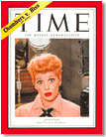

p. 70: “…But five years ago you ripped my heart out like a blue chip stamp to stick it into …”

http://www.retro-housewife.com/1960-coupons-saving-money.html:

Stretching the Household Budget in the 1960s

Blue Chip Stamps, Green Stamps, Plaid Stamps, Oh what fun! I remember the Blue Chip and Green Chip stamps from my childhood. I thought they were great because to me, it seemed like we had an endless supply of stickers. Before my Mom wizened up and taught me to paste them into the little paper books, I and my little sister took full advantage of their decorative properties and pasted them on walls, books, suitcases, my nose and my little sister's forehead. My mother didn't much care for that, so she finally gave us a lesson in Blue Chip Stamps. After that, I was always on the look-out for new sources of the little blue and white stamps because of all the great things you could trade them in for. And, as my mother informs me, the items available by redeeming the blue chips were "very good quality".
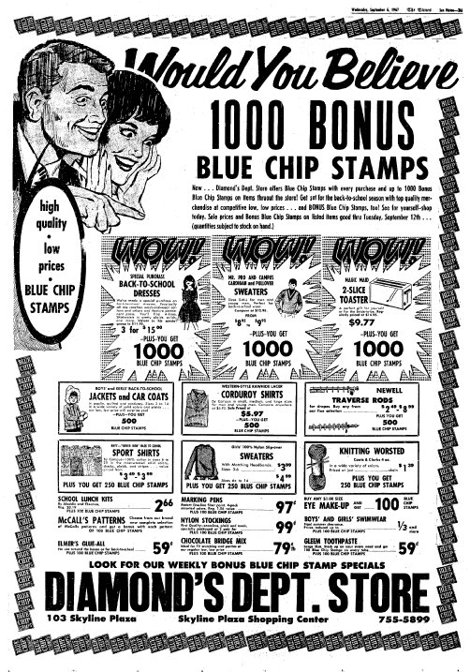
Blue Chip Stamps were used as a promotional tool in the 1960s - 1970s to attract customers and to keep them coming back! The ad shown above is from 1967 and was printed in the San Mateo Times in California!

p. 70: Diamond’s brother, Hope (UGH: as in “Hope Diamond,: http://www.si.edu/Encyclopedia_SI/nmnh/hope.htm) : “… labeled a communist, blacklisted …” references The Second Red Scare, c. 1947-1955, and particularly the Hollywood hearings (various years) in which Congressional politicians pressured actors, producers, and directors to “name names” of “fellow travelers” who were or had been members of the Communist Party USA.
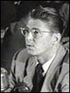

Ronald Reagan before Congressional hearings as President of the Screen Actors Guild, 1947.
http://www.cnn.com/SPECIALS/cold.war/episodes/06/documents/huac/

p. 71: “ … my hand rang….” This refers to the television show that spoofed the Cold War spy culture, “Get Smart.” (A shoe phone was used in the series.) Indeed, one episode of “Get Smart” spoofed another television spy show, “I Spy,” which was produced by Desilu Productions (the production company of Lucille Ball and Desi Arnaz …). http://imdb.com/title/tt0058805/ http://en.wikipedia.org/wiki/Get_Smart; http://en.wikipedia.org/wiki/I_Spy

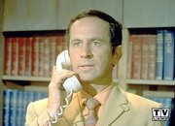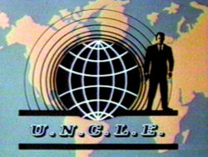

pp. 71-72: “Fred and Ethel” were Lucy and Ricky’s friends on their television show, “I Love Lucy,” but Ethel and Julius Rosenberg were hanged as spies in the 1950s. See http://www.tvland.com/shows/lucy/ and http://www.law.umkc.edu/faculty/projects/ftrials/rosenb/ROSENB.HTM

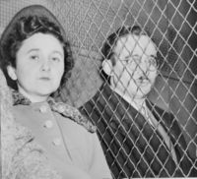 Ethel and Julius 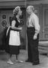 Fred and Ethel

p. 72: “Bugs Bunny Kiss”: http://en.wikipedia.org/wiki/Bugs_Bunny

p. 72: Baby Boom: In the U.S., the generation born during the postwar period is referred to as “the Baby Boom generation.” Exact dating is in dispute. For the latest production re the “Baby Boom,” see http://www.boomercentury.com/

See also http://en.wikipedia.org/wiki/Baby_boom; http://geography.about.com/od/populationgeography/a/babyboom.htm

p. 72: “Maternity ward bombings” is a bad pun on “abortion clinic bombings,” which occurred in the1980s and 1990s. See http://www.msnbc.com/modules/clinics/

p. 73: Tony the Tiger: Introduced in 1951, the Kellogg ad for frosted flakes became an ad industry icon. See http://adage.com/century/icon09.html



p. 73: Dorothy Parker Writer and critic for “Vanity Fair” and later “The New Yorker”;authored numerous volumes of short stories; was a member of the NYC Algonquin Round Table group of writers and artists; popular culture personality during the 1920s-1960s; screen writer in Hollywood; blacklisted in the early 1950s.
http://en.wikipedia.org/wiki/Algonquin_Round_Table; http://en.wikipedia.org/wiki/Dorothy_Parker

p. 74: Cold War … Domino Theory … Vietnam: The Cold War, c. 1947-1989, pitted the ideology of western, Judeo-Christian capitalism (led by the U.S. and Western Europe) against the ideology of communism (led by the Soviet Union and China, though not always in concert). The Domino Theory postulated that if the West let one country go communist, the other countries nearby would go communist, falling like dominoes. This was usually applied to Asia, but included Latin America as well. Vietnam, or IndoChina, had been governed by outside nations since the mid-19th century (France, Japan, France again, then the U.S.). U.S. leaders in the 1960s cited the Domino Theory to sustain American support for South Vietnam, whose leaders opposed the communist-inspired North. …

p. 74: Domino’s Pizza lawsuit:
See “JURY AWARD SPURS DOMINO'S TO DROP DEADLY POLICY” http://www.gtla.org/public/news/dominos.html

p. 75: “Jo Chi Minh” is pun on Ho Chi Minh, leader of the North Vietnamese communist government.

p. 75: “Pucker up and blow”: “You know how to whistle don’t you? Put your lips together and blow.” Lauren Bacall (Marie “Slim” Browning) to Humphrey Bogart (Harry “Steve” Morgan) in their first film together, “To Have and Have Not” (1944).
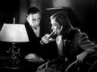

p.75: “Are you on their side or our side?”

“I’m on my own side.”

Another Bogart reference, of course: “Casablanca” (1942) “I stick my neck out for nobody.” And countless other Bogart films….

p. 76: “Another monk is setting hisself on fire!”

South Vietnam’s government in the early 1960s tried to curb the practice of Buddhism; Buddhist monks protested the government’s actions by setting themselves on fire.

http://www.vietnampix.com/fire1.htm

p. 76: “Here’s looking at you, kid.” Bogart again. Casablanca again.

p. 76: Kennedy, Martin Luther King, Malcolm X, and Robert Kennedy were all assassinated in the 1960s. Anne Murray was not.

The script for the voice-over reads as follows:

We hear JFK say, “Ask not what your
country can do for you” then the BANG of a gunshot. Then
Martin Luther King: “I have a dream!” BANG! Malcolm X:
“By any means necessary.” BANG! RFK: “To follow in the
footsteps of my brother.” BANG! Anne Murray: “Spread your
tiny wings and fly away.” BANG! BANG! BANG!

Sound Designer Keya Myers-Alkire did some research and discovered that the quotations for JFK, Martin Luther King, and Malcolm X were actually uttered by the men (and the production uses actual audio clips); the quotation attributed to Robert Kennedy apparently was not. This appears to be a case where the playwrights made something up to fit the joke ….

p. 76-77: Neil Armstrong and Buzz Aldrin were the first 2 humans to walk on the moon in July 1969. Some controversy exists over what exactly Armstrong uttered, but the text in the play is probably preferred by most….
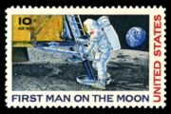

p. 77: Ken Kesey was a famous author/cultural icon who connected the “Beat” generation of the 1950s to the so-called “hippies” (more correctly, counter-culture) of the 1960s. He was author of One Flew Over the Cuckoo’s Nest (1962). http://en.wikipedia.org/wiki/Ken_Kesey#One_Flew_Over_the_Cuckoo.27s_Nest
Timothy Learyhttp://en.wikipedia.org/wiki/Timothy_Leary
: “was an American writer, psychologist, advocate of psychedelic drug research and use, and one of the first people to be buried in space. As a 1960s counterculture icon, he is most famous as a proponent of the therapeutic and spiritual benefits of LSD. He coined and popularized the catch phrase ‘Turn on, tune in, drop out.’”

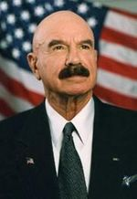 G. Gordon Liddy (Conspirator Guy?) had Timothy Leary arrested ….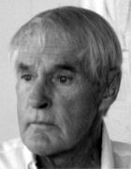
Liddy went to jail for his role in Watergate. See below (pp. 78-79)

Beginning in 1982, Liddy and Leary teamed-up to debate one another (now more friendly to one another)—both of them ex-cons. The lecture circuit was apparently lucrative for both.

p. 77: “I’m Uncle Sam.
Uncle Sam-I-am.
Do you like my war in Vietnam?”

This is satire employing the work of Dr. Suess, “Green Eggs and Ham.” Published in 1960, the children’s story has deep cultural resonance. See http://en.wikipedia.org/wiki/Green_Eggs_and_Ham and http://en.wikipedia.org/wiki/Green_Eggs_and_Ham_in_popular_culture

p. 77: Gulf of Tonkin: 1964 an incident in the Gulf of Tonkin near North Vietnam led Congress to pass the Gulf of Tonkin Resolution, which gave President Lyndon B. Johnson wide latitude to expand the war in Vietnam.
Operation Rolling Thunder was President Johnson’s bombing campaign of North Vietnam, 1965-1968. It failed to bring the North Vietnamese to the negotiating table. Flaming Dart was a military operation in Vietnam in 1965.
My Lai refers to the war crime in which American soldiers in March 1968 indiscriminately killed civilians, mostly women and children, in a village in Vietnam.
Some anti-war protesters burned their draft cards (identification cards) at anti-war rallies in the 1960s.
“Burning bras” refers to a myth: “ See Bra-Burning Feminists: NOT” at http://womenshistory.about.com/od/mythsofwomenshistory/a/bra_burning.htm and http://www.snopes.com/history/american/burnbra.htm
Despite some success in the Civil Rights Movement (e.g., the Civil Rights Act of 1964 and the Voting Rights Act of 1965), many urban areas between 1965 and 1968 across the U.S. erupted into racial riots, particularly in the summers.
In May of 1970, Ohio National Guardsmen, poorly trained and led, opened fire on student protesters at Kent State; 4 students lay dead.
Agent Orange was a chemical used in Vietnam to kill the forest cover over the so-called Ho Chi Minh Trail, the routes through which the Viet Cong and communists from North Vietnam were supplied in the south.

p. 78-79: Watergate Hotel was the location of the Democratic Party headquarters, which Republican operatives broke into during the 1972 campaign, which in turn led to the Watergate scandal of Richard Nixon’s presidency. In his rise to political power in the postwar era, Nixon did make a name for himself as a “communist hunter.” As president, Nixon opened up relations with the Soviet Union and China (détente—a French word meaning relaxing/easing of tensions). Nixon claimed, “I am not a crook,” in a 1973 interview. While particularly defending charges against him re Watergate, the phrase also echoes his famous “Checkers” speech during the election campaign of 1952. Nixon employed the double-victory sign before leaving the White House after his resignation.

p. 80: President Gerald Ford had a reputation for falling down and being klutsy, a reputation Chevy Chase, the SNL comedian, mined for millions of dollars…. 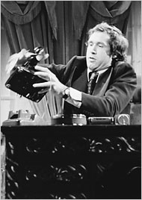 Edie Baskin/NBC

In 1973 and again in 1979, Americans sat in their cars in long lines waiting to fill up with gas. OPEC (Organization of Petroleum Exporting Countries) had successfully restricted the supply of oil to the world’s markets.
In 1979, Iranian revolutionaries seized U.S. embassy personnel and held them hostage until early 1981. By that time, Ronald Reagan, with his second wife Nancy, had finally won the Republican nomination for president and the national election against Jimmy Carter, who appeared out of touch (e.g., using “malaise” to describe the … malaise dragging down Americans at the time) and helpless in the face of the Iranian hostage situation. The Reagans, of course, had been Hollywood actors. Reagan had been president of the Screen Actors’ Guild in the late 1940s. [See above p. 70.]

pp. 80-81: Many pundits believed that Nancy Reagan followed astrology and manipulated her husband to do as she thought best for his interests. Thus, Nancy manipulating a dummy ….
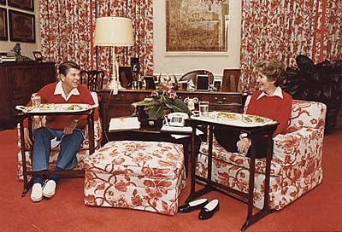Eating on TV trays in the White House (Nov. 6, 1981)
Donald Regan was President Ronald Reagan’s Secretary of the Treasury (1981-85) and Chief of Staff (1985-1987). The Iran-Contra scandal led in part to his leaving the administration. John Hinckley tried to assassinate President Reagan in March 1981 in order to impress actress Jodie Foster.

p. 82: Marine Colonel Oliver North was at the center of the Iran-Contra scandal (a scheme in which U.S. missiles were sold to the Iranians and the proceeds funded the Contras, a group opposed to the communist-leaning Sandanista government in Nicaragua). Iran was fighting Iraq and needed arms; Iran apparently had some influence with other groups who had taken hostages in the Middle East ….
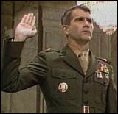

p. 82: White House-Kremlin hotline: A direct phone line was established between the White House and the Kremlin after the Cuban Missile Crisis of October 1962. The goal was to prevent tensions/conflicts from rising to the same level again. See “red telephone”: http://en.wikipedia.org/wiki/Red_telephone

p. 82: Mikhail refers to the General Secretary of the Communist Party of the Soviet Union (i.e., the leader) in the 1980s, Mikhail Gorbachev. He helped move along the decline of the communist government with his policy of glasnost (openess). Raisa was his wife.
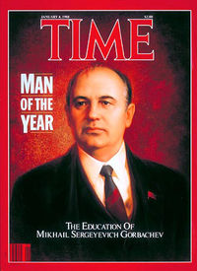 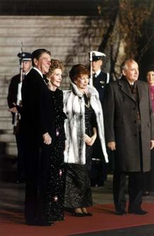Pres. Ronald Reagan, Nancy Reagan, Raisa Gorbacheve, and Mikhail Gorbachev, December 8, 1987, after the signing of the INF Treaty.

"My fellow Americans, I've signed legislation that will outlaw Russia
forever. We begin bombing in five minutes."
- Ronald Reagan, about to go on the air for a radio broadcast,
unaware that the microphone was already on

[need a date …]

p. 82: Berlin Wall/Checkpoint Charlie: The third of three (Alpha, Bravo, Charlie) crossing points from West to East along the Berlin Wall. http://www.dailysoft.com/berlinwall/history/checkpoint-charlie.htm

p. 82: “Just say no Spade.” Nancy Reagan sponsored the “Just Say No” anti-drug crusade of the 1980s.

p. 83: One of Reagan’s memorable performances as an actor was in the film, “Bedtime for Bonzo” (1951), where he is a surrogate father for a chimpanzee. http://www.imdb.com/title/tt0043325/

p. 83: Iron Curtain: In 1946 Winston Churchill, Prime Minister of England, asserted that the Soviet Union had put up an iron curtain separating East Europe from Western Europe, separating communism from freedom. http://www.fordham.edu/halsall/mod/churchill-iron.html

p. 83: Sing Sing: Prison 30 miles north of NYC. From http://en.wikipedia.org/wiki/Sing_Sing:
“Gangster movies helped make the prison a legend far beyond New York; they included The Big House (1930), Castle on the Hudson (1940), and 20,000 Years in Sing Sing (1932), the latter based on a book by Warden Lawes.
"The expression "sent up the river" refers to Sing Sing.^{[citation needed]} Other than Alcatraz, it is the most famous prison in American popular culture. “

p. 83: disco: A much maligned style of music (claimed by Philadelphia) from the 1970s. Short for the French “discotheque”—dance club. “Saturday Night Fever” (1977) marked the highpoint/lowpoint. http://www.imdb.com/title/tt0076666/ Some ties to Motown and NYC soul, but percussion of Philly dominates.

p. 84: Harley Davidson motorcycle: President Reagan saved this American icon with high tariffs against better-made Japanese motorcycles.

pp. 84-85: A FRUIT STAND … A NURSERY SCHOOL … THE ATLANTIC OCEAN: Parody of high-speed chases from such Hollywood films such as “Bullitt” (1968) and “The French Connection” (1971).
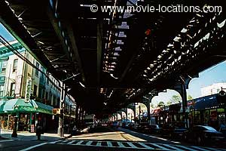The greatest screen car chase: New Utrecht Avenue, Borough Park, Brooklyn
http://www.movie-locations.com/movies/f/frenchconn.html

p. 86: “Banzai!”: From: http://en.wikipedia.org/wiki/Banzai Banzai may refer to:
- A traditional Japanese exclamation meaning "Ten thousand years"
  - Banzai charge or banzai attack, a last desperate military charge
- Banzai (television show), a spoof of Japanese gameshows
  - Banzai (the DVD betting game), a DVD game based on the television show
- Banzai (The Lion King), a hyena character from the 1994 Disney animated film The Lion King
- Buckaroo Banzai, a character from the film The Adventures of Buckaroo Banzai Across the 8th Dimension
- The German edition of the Weekly Shonen Jump manga
- The Banzai Drop is a professional wrestling move …

p. 88: “… and I shot JR …”refers to the infamous television series, “Dallas,” which was a successful night-time soap opera, 1978-1991 (14 seasons) around the world, not just in the U.S.
http://www.ultimatedallas.com/
From http://en.wikipedia.org/wiki/Dallas_(TV_series):
“ The Dallas series is probably best-known for the central character of J.R. Ewing, the vain, greedy, scheming, crass oil baron played by Fort Worth native Larry Hagman for the show's entire run. Ironically, J.R. was only meant to be a supporting character when the show premiered (the show was originally to be based around J.R.'s brother Bobby and his new bride Pam); however, the popularity of J.R. took off and he became the focus of the series.”
JR was shot in the last episode of season #2. An actors’ strike the next autumn delayed resolution of whether he lived (yes) and who shot him (look it up).

p. 88: “I whacked Nancy Kerrigan on the knee…” refers to an attack on skater Kerrigan in 1994 before the Olympics. The ex-husband of fellow skating competitor Tonya Harding hired another person to attack Kerrigan. Self-importance/preciousness of the skating community collided with popular culture; result: The latter turned on Kerrigan! http://en.wikipedia.org/wiki/Nancy_Kerrigan

If you do not know the reference to the following, click on the links!:
p. 88: “… I shrank the bloody glove so it wouldn’t fit O J anymore …” http://www.cnn.com/US/OJ/evidence/glove/index.html

p. 88: “… and I told President Clinton, ‘Go ahead! She’s an intern! Who cares?’” http://en.wikipedia.org/wiki/Monica_Lewinsky [See same for “Head of State” down the page ….]

p. 88: “I was Sonny bono’s ski instructor” http://en.wikipedia.org/wiki/Sonny_Bono

p. 88: “And I fondled Kathleen Willey” http://en.wikipedia.org/wiki/Kathleen_Willey

p. 88: “Hugh Grant” http://en.wikipedia.org/wiki/Hugh_Grant

p. 88: “Whitewater”: http://en.wikipedia.org/wiki/Whitewater_scandal

p. 88: “… the finest president ever elected by the United States Supreme Court.” Refers to Democrats’ view of 2000 presidential election.

p. 89: “Jack Daniels and Johnnie Walker”: Two whiskeys, of course. Both spelled correctly.

Jimmie Walker played “J.J.” on “Good Times” between 1974 and 1979. http://www.tv.com/good-times/show/602/summary.html
There is an English DJ named Johnnie Walker: http://en.wikipedia.org/wiki/Johnnie_Walker_(DJ)

p. 89: Lucy not Lucy but Louie and “Crying Game” (1992): For the plot, see http://en.wikipedia.org/wiki/The_Crying_Game “Love interest” not what he thought. http://www.imdb.com/title/tt0104036/ Won 18 awards (one Oscar, for best screenplay) and was nominated for 34 total.

p. 90: “Jimmy Hoffa … in the concrete.” Rumors abound that the labor leader was buried in concrete somewhere …. From: http://en.wikipedia.org/wiki/Jimmy_Hoffa
“James Riddle "Jimmy" Hoffa (February 14, 1913, disappeared July 30, 1975, date of death unknown) was an American labor leader. As the president of the International Brotherhood of Teamsters from the mid-1950s to the mid-1960s, Hoffa wielded considerable influence. He is also well-known in popular culture for the mysterious circumstances surrounding his unexplained disappearance and presumed death.”

p. 90: Sean Connery is from Scotland; the Beatles were from England; and Canada is … Canada.

Happy Ending

p. 91: “Arawak Indians” See http://en.wikipedia.org/wiki/Arawakan_languages and http://en.wikipedia.org/wiki/Arawak

For information on Laugh-in, which was an inspiration for some of CATCO’s stageing, see: http://www.timvp.com/laughin.html http://www.webpan.com/thelaughin/home.htm
http://www.webpan.com/thelaughin/midi.htm

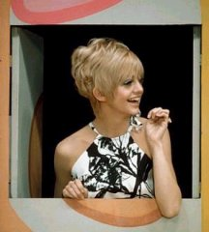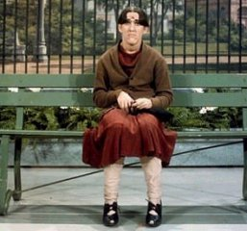

http://www.museum.tv/archives/etv/R/htmlR/rowanandmar/rowanandmar.htm

http://www.tv.com/rowan-and-martin-s-laugh-in/show/1351/summary.html

